# Test Case Screenshots

1. Show that if you define more than the MAX number of variables, then you error.  
   (Max was set to 5 for this example)  
   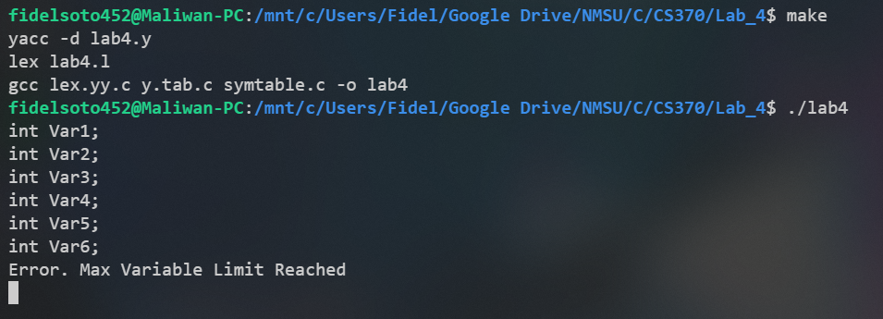
2. Show that you cannot declare a variable more than once  
   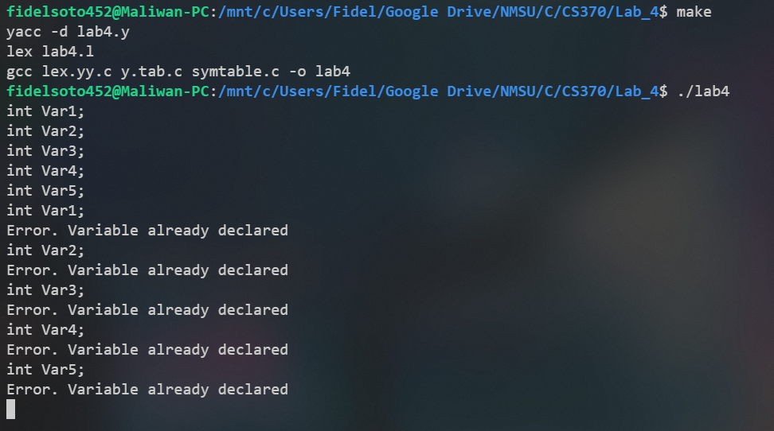
3. Show that you cannot use a variable that is not defined  
   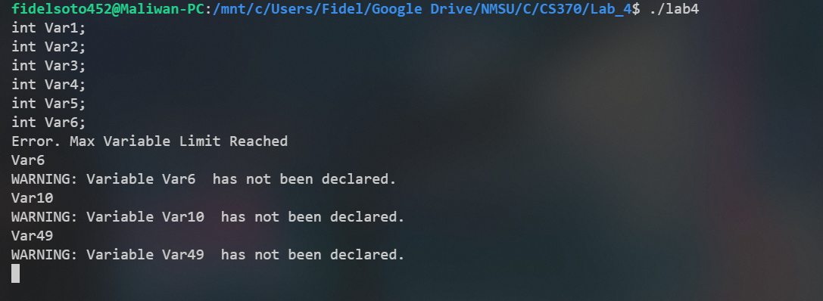
4. Show that a declared variable can be set and used (left and right hand side)  
   